Running Sricam viewer on Window 10.

The Network Viewer from Sricam for your Windows 10 PC must be run in Internet Explorer.

It turns out Microsoft has replaced the default browser in Windows 10 (edge?). You can still run Internet Explorer (IE) by following the instructions below.

Click the windows icon (bottom left corner shown below)



LEFT Click “All apps”

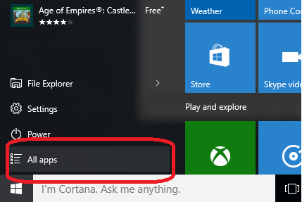

Scroll Down and CLICK “Windows Accessories”

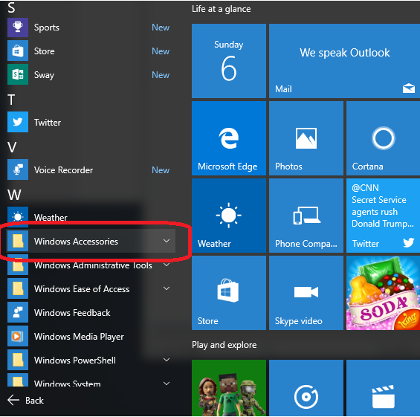

CLICK Internet Explorer

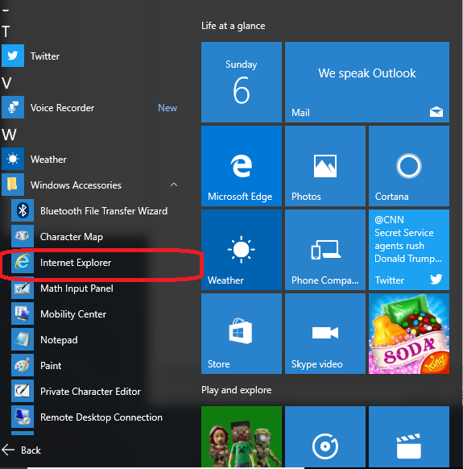

Type in the following address (or copy this address) <http://www.videoipcamera.cn/view/>. (Clicking this link will not work as the default browser for is not Internet Explorer)



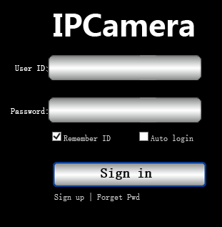

Notes for users.

You can create an Internet Explorer Tab on your “task bar” by RIGHT Clicking the Internet Explorer tab and selecting “more” and selecting “Pin To Taskbar”.